“Expert Cloud Consulting” -

Kubernetes Fundamentals
06. January .2025
Version 1.0
—
Contributed by Tejal Kale
Approved by (In review)
Expert Cloud Consulting
Office #811, Gera Imperium Rise,
Hinjewadi Phase-II Rd, Pune, India – 411057

“Expert Cloud Consulting”
Kubernetes Fundamentals

Contents
- Contents 2
- General Information 3
  - Document / GitHub URL(s) 3
  - Document Purpose 3
  - Document Revisions 3
  - Document References 3
- Prerequisite 3
  - Virtual machine 3
  - Required Software 4
- Document Overview 6
- Application Components Documentation 7
  - Overall Application Architecture 7
  - Frontend Component (React.js) 7
  - Backend Component (Flask) 8
  - Database (PostgreSQL) 9
  - Deployment Considerations 9
- Implementation Details 9
  - Docker Implementation 9
  - Kubernetes Manifests 11
  - Deployment Steps 12
  - Monitoring and Scaling 14
  - Testing and Verification 15
  - Live Application 15
  - Load Testing Procedure 16
- Troubleshooting Guide 19
  - Common Issues 19
- 0 Conclusion 19
  - Key Achievements 19
  - Primary Benefits 19
  - Recommendations 19

General Information:

  - Document Purpose
This technical documentation outlines the implementation of a multi-tier application deployment on Kubernetes, including frontend (React), backend (Flask), and database (PostgreSQL) services. The documentation covers configuration management using ConfigMaps and Secrets, and implementation of Horizontal Pod Autoscaling (HPA).

Prerequisite:
  - Virtual machine
    - Created VM in Aws cloud console for development and deployment
    - Sufficient resources allocated for running Kubernetes cluster.

  - Required Software
    - Docker (>= 20.10.0)

- Update system packages:
sudo apt update
sudo apt upgrade

- Install required dependencies:
sudo apt install ca-certificates curl gnupg lsb-release

- Add Docker's official GPG key:
sudo mkdir -p /etc/apt/keyrings
curl -fsSL https://download.docker.com/linux/ubuntu/gpg | sudo gpg --dearmor -o /etc/apt/keyrings/docker.gpg

- Set up Docker repository:
echo \
"deb [arch=$(dpkg --print-architecture) signed-by=/etc/apt/keyrings/docker.
gpg] https://download.docker.com/linux/ubuntu \
$(lsb_release -cs) stable" | sudo tee /etc/apt/sources.list.d/docker.list > /dev/null

- Install Docker Engine:
sudo apt update
sudo apt install docker-ce docker-ce-cli containerd.io docker-buildx-plugin docker-
compose- plugin

- Verify installation:
docker –version

- kubectl (latest stable version)
- Update package list and install dependencies:

sudo apt update && sudo apt install -y apt-transport-https ca-certificates curl

- Download and add the Kubernetes signing key:

curl -fsSL https://packages.cloud.google.com/apt/doc/apt-key.gpg | sudo gpg --dearmor -o
/usr/share/keyrings/kubernetes-archive-keyring.gpg

- Add the Kubernetes repository:

echo "deb [signed-by=/usr/share/keyrings/kubernetes-archive-keyring.gpg] https://apt.kubernetes.io/ kubernetes-xenial main" | sudo tee /etc/apt/sources.list.d/kubernetes.list

- Update package list and install kubectl:

sudo apt update && sudo apt install -y kubectl

- Verify installation:
kubectl version --client --output=yaml

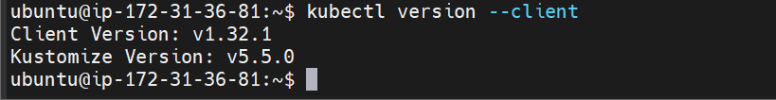

Install Kind
1. Download Kind binary:
curl -Lo ./kind https://kind.sigs.k8s.io/dl/v0.20.0/kind-linux-amd64

2. Make the binary executable:
chmod +x ./kind

3. Move it to a directory in your PATH:
sudo mv ./kind /usr/local/bin/kind

4. Verify Installation
Run the following command to confirm that Kind is installed:
kind version

Document Overview:

This implementation sets up a Kubernetes cluster using kind, deploys a multi-tier application,

manage configurations with ConfigMaps and Secrets, enables Horizontal Pod Autoscaling,

and includes testing and verification.

Architecture Overview

    - Frontend: React.js Single Page Application (SPA)
    - Backend: Flask Python Web Application
    - Database: PostgreSQL
    - Deployment: Kubernetes (K8s) Cluster

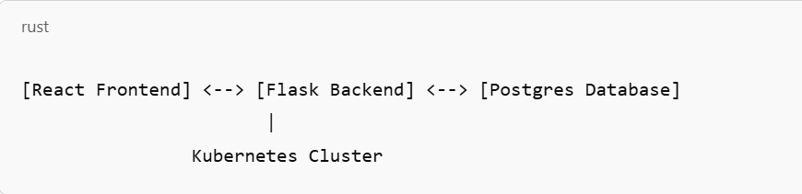

Database Model
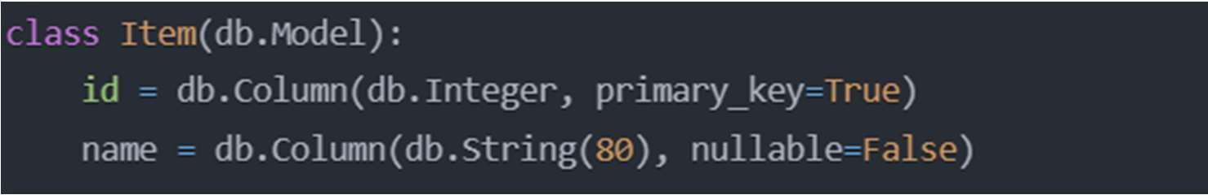

API Endpoints
- GET /items
  - Retrieves all to-do items
  - Returns JSON array of items
  - Provides full list of existing items

- POST /items
  - Adds a new to-do item
  - Accepts JSON payload with item name
  - Creates and saves new item to database
  - Returns created item details

Configuration Details

  - Database URI: postgresql://user:password@db:5432/mydb
  - Runs on all network interfaces (host='0.0.0.0')
  - Debug mode enabled for development

Database Initialization
  - Automatically creates database tables on application startup
  - Uses SQLAlchemy's db.create_all() method

  - Database (PostgreSQL)

Schema
- Table: items
- Columns:

  - id: Primary key, integer
  - name: Todo item name, string (max 80 characters)

Connection Parameters
    - Database Name: mydb
    - User: user
    - Password: password
    - Host: db (postgres-75896f4b4b-q847s)
    - Port: 5432

  - Deployment Considerations

Kubernetes Resources:
    - ConfigMaps for configuration
    - Secrets for sensitive data
    - Horizontal Pod Autoscaler (HPA)
    - Services for inter-component communication

Network Configuration:
    - Frontend exposed via NodePort
    - Backend and Database as ClusterIP services
    - Cross-component communication via Kubernetes DNS

Implementation Details
  - Docker Implementation Frontend Dockerfile
    - Installing dependencies first (leveraging Docker's layer caching)
    - Copying application code after dependency installation
    - Using a specific Node.js version rather than 'latest'
    - Setting up a dedicated working directory

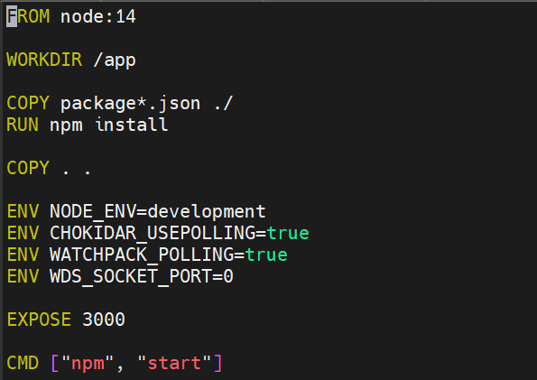

Backend Dockerfile
    - Using a specific Python version (3.8) instead of 'latest' for better stability and reproducibility
    - Setting up a dedicated working directory (/app) for better organization and isolation
    - Installing dependencies first by copying requirements.txt before full codebase (leveraging Docker's layer caching)
    - Using pip's requirements file for deterministic dependency installation
    - Copying application code after dependency installation to optimize rebuild times
    - Exposing port 5000 for the Python web application
    - Using a clear CMD instruction to run the main application file (app.py)
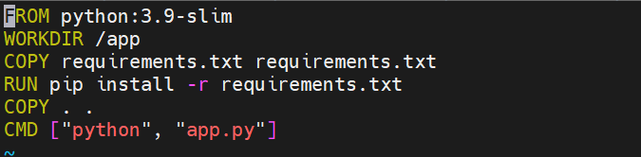

Docker Build Commands
    - Building frontend and backend Docker images separately under a common repository (prasadsb/3-tier)
    - Using the -t flag to tag images appropriately with descriptive names (frontend-latest and backend-latest)
    - Building images from their respective directories (./frontend and ./backend)
    - Pushing both images to Docker Hub for distribution and deployment

The commands show a typical workflow for:

- Building the frontend image
- Building the backend image

- Pushing frontend image to Docker Hub
- Pushing backend image to Docker Hub
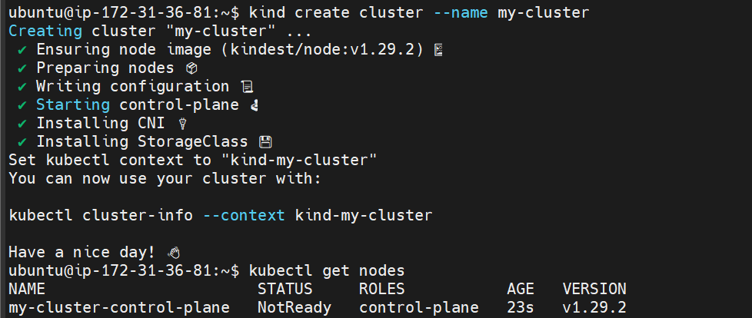

  - Kubernetes Manifests

All the manifests file are stored in GitHub repo
Check it out: https://github.com/Prasad-b-git/3-tier-application.git

Frontend Configuration (frontend.yml)

- This is a Kubernetes configuration for a frontend application that includes multiple components
- a ConfigMap for environment variables, a Deployment to manage the application pods, a Service for network access, and a Horizontal Pod Autoscaler (HPA) for automatic scaling.

- The Deployment configures a container using the image 'prasadsb/3-tier:frontend-latest', running on port 3000 with specific resource limits (512Mi memory, 200m CPU) and requests (256Mi memory, 100m CPU). It starts the application using the "npm start" command.

- The Service is configured as NodePort type, making the frontend accessible from outside the cluster on port 31239, while internally routing traffic to port 3000 where the application is running.

- The Horizontal Pod Autoscaler (HPA) is set up to automatically scale the frontend deployment between 1 and 3 replicas based on CPU utilization, triggering when average CPU usage reaches 70%. It includes specific scaling policies with a 60-second window for scaling down and immediate scaling up.

- The ConfigMap includes environment variables for the frontend application, specifically setting WATCHPACK_POLLING to "true" and WDS_SOCKET_PORT to "0", which are typically used for development server configurations in React applications.

Database Configuration (postgres.yml)

- This is a complete Kubernetes configuration for a PostgreSQL database setup, comprising multiple components including a ConfigMap for database configuration, a Secret for sensitive credentials, a Persistent Volume Claim for data storage, a Deployment for running the database, and a Service for network access.

- The security is carefully configured with base64 encoded credentials stored in Secrets (username and password) and specific security contexts (fsGroup, runAsUser, and runAsGroup all set to 999) to ensure proper file permissions and security in the PostgreSQL container.

- The Deployment uses the postgres:13 image with defined resource limits (500m CPU, 512Mi memory) and requests (100m CPU, 256Mi memory), and mounts a persistent volume at
/var/lib/postgresql/data to ensure data persistence across pod restarts.

- The Persistent Volume Claim requests 1Gi of storage with Read Write Once access mode, ensuring that the database data is preserved even if the pod is rescheduled to a different node in the cluster.

- The Service is configured as ClusterIP type (internal access only) exposing PostgreSQL's standard port 5432, allowing other applications within the cluster to connect to the database using the service name 'postgres' as the hostname.
Backend Configuration (backend.yml)

- This Kubernetes configuration defines a backend service setup with three main components: a ConfigMap for environment variables, a Deployment for running the application, and a Service for network communication.

- The ConfigMap stores environment configurations including the Flask environment setting and the PostgreSQL database connection URL, which references the previously configured postgres service, showing how the backend integrates with the database tier.

- The Deployment uses the custom image 'prasadsb/3-tier:backend-latest' and is configured with specific resource constraints (512Mi memory limit, 200m CPU limit) and requests (256Mi memory, 100m CPU), ensuring efficient resource utilization and performance.

- The Service is set up as ClusterIP type, making the backend accessible only within the cluster on port 5000, which is appropriate for internal communication between the frontend and backend components.

- The entire configuration demonstrates a typical backend service setup in a three-tier architecture, where it acts as an intermediary between the frontend and database layers, with appropriate resource management and networking configurations.

  - Deployment Steps

Cluster Configuration (cluster.yml)

This YAML configuration defines a Kind (Kubernetes in Docker) cluster setup with two nodes
- one control-plane node that manages the cluster and one worker node for running workloads.

- On the worker node, there's a specific port mapping configuration that exposes port 31239 from the container to the same port (31239) on the host machine using TCP protocol, allowing external access to services running inside the cluster.
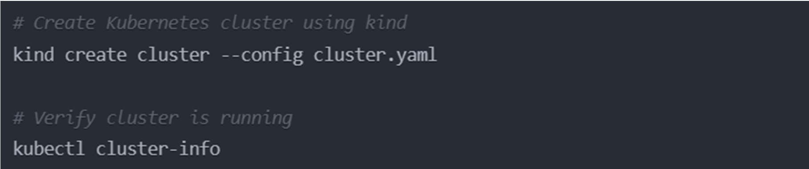

Cluster Setup

- The first command creates a new Kubernetes cluster using Kind (Kubernetes in Docker) by applying the configuration specified in the 'cluster.yaml' file, which sets up the cluster structure and node configurations.

- The second command uses kubectl to verify that the cluster is operational by displaying connection information for the Kubernetes control plane and CoreDNS service, confirming that the cluster is running and accessible.

Deploy Applications

- The code demonstrates a sequential deployment process in Kubernetes, starting with PostgreSQL as the database by applying its configuration from 'postgres.yml' file.

- After deploying PostgreSQL, the code includes a wait condition that ensures the PostgreSQL pod is completely ready before proceeding with the next step, using the label 'app=postgres' to identify the correct pod.

- The backend service is then deployed using its configuration from 'backend.yml', followed by another wait condition to ensure the backend pod (identified by 'app=backend') is fully ready before continuing.

- Finally, the frontend application is deployed by applying the configuration from 'frontend.yml', completing the full stack deployment process.

- The code follows a logical deployment order (database → backend → frontend) with wait conditions between deployments to ensure dependencies are ready, which is crucial for proper application functionality.

Verify Deployment

- The code shows a series of Kubernetes commands used to verify the status of different components in the cluster, starting with checking all running pods using 'kubectl get pods' and then examining services with 'kubectl get svc'.

- The commands continue with checking the status of Horizontal Pod Autoscalers (HPA) using 'kubectl get hpa' and Persistent Volume Claims (PVC) using 'kubectl get pvc', providing a comprehensive overview of the cluster's key resources and their current state.
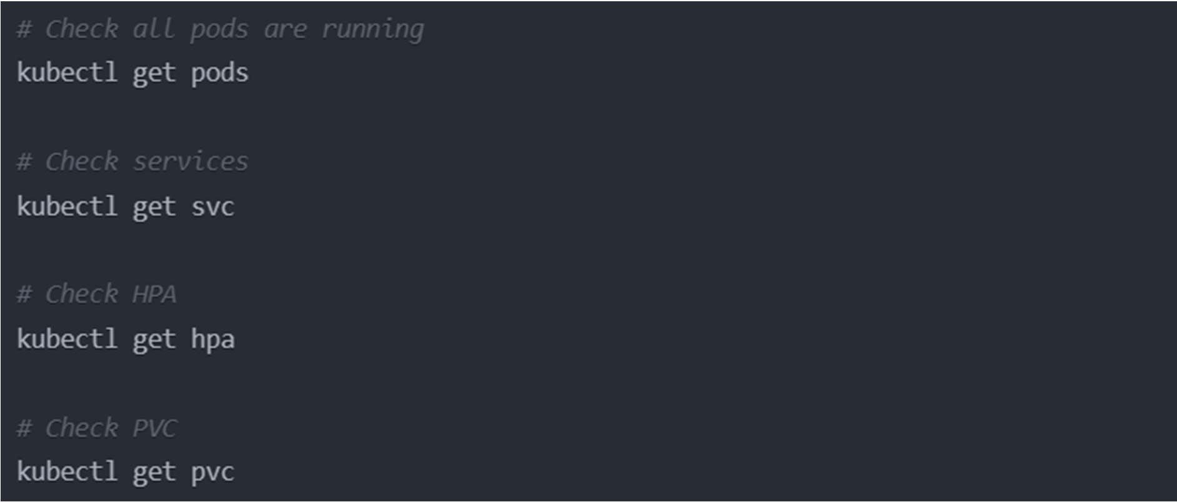

  - Monitoring and Scaling Monitor HPA
- The first command 'kubectl get hpa frontend-hpa --watch' continuously monitors the Horizontal Pod Autoscaler metrics for the frontend application, showing real-time updates about scaling decisions and current resource utilization.

- The second command 'kubectl top pods' displays the CPU and memory usage metrics for all pods in the cluster, providing a snapshot of resource consumption that helps in monitoring pod performance and identifying potential resource bottlenecks.
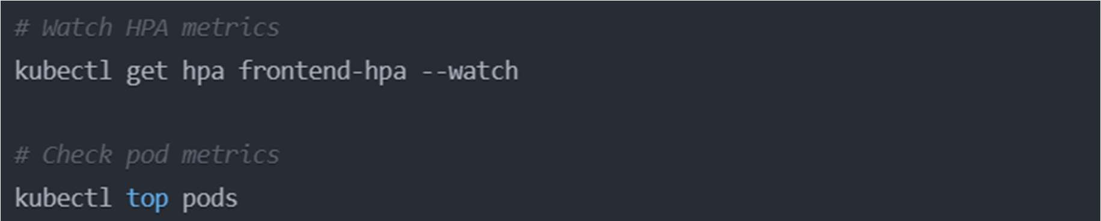

Test Autoscaling
- The first command uses 'kubectl exec' to access a shell (/bin/sh) inside the frontend pod, allowing direct interaction with the container, while the second command uses Node.js to generate continuous load by running an infinite while loop.

- The third command 'kubectl get pods -w' monitors pod status in real-time in a separate terminal window, allowing you to observe how the system responds to the generated load, particularly useful for watching pod scaling behavior under stress.

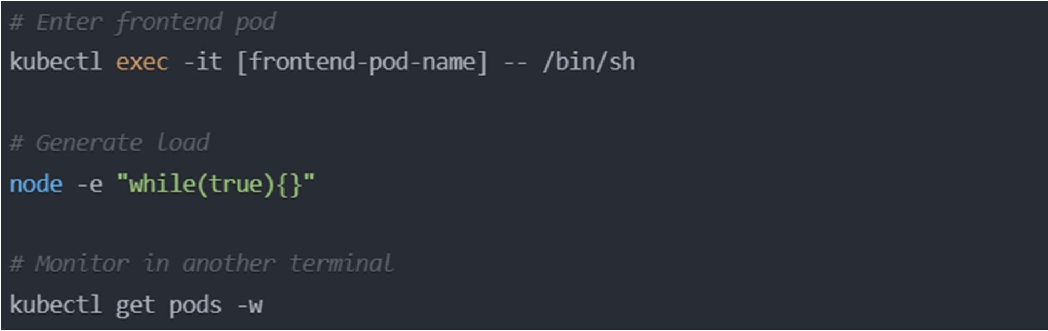

Testing and Verification:

  - Live Application
- Access frontend Application:
Access the frontend Application using instances IP address and the attached port.

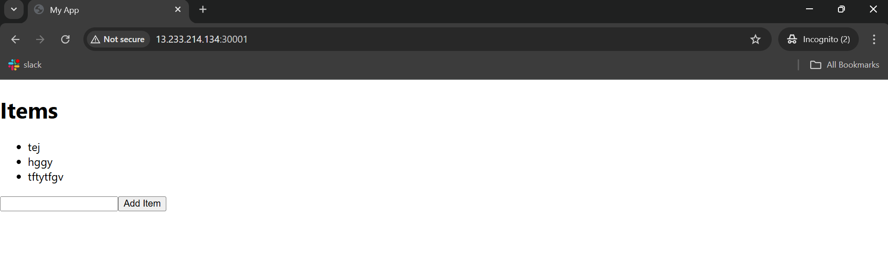

- Check the database the items are existed or not. The Data is existed in the postgres table.
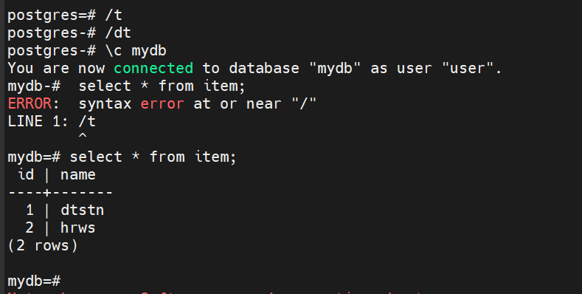

  - Load Testing Procedure

- Access frontend pod:
To access frontend pod, use this command:
Kubectl exec –it {frontend_pod name} -- /bin/sh
This command will help you to generated load to the frontend pod. Node –e “while(true){}”

- Cpu Usage
Open another terminal to check the Cpu utilization Check the Cpu usage by use this command Kubectl get hpa frontend-hpa –watch

This will show live Cpu usage of frontend pod
In my case the usage hit spike from 4% to 82% to 200% and new pods are getting created. To check the pods, use this command.
Kubectl get pods

- Auto-scale down behavior:
scaleDown:
stabilizationWindowSeconds: 60 # Wait 1 minute before scaling down
policies:
- type: Percent
value: 100
periodSeconds: 15
scaleUp:
stabilizationWindowSeconds: 0 # Scale up immediately when needed
policies:
- type: Percent

value: 100
periodSeconds: 15

This is the policies added to scale-down the pods after the Cpu utilization spike down. In my case, Cpu usage down from 200% to 177% to 31% to 4%.
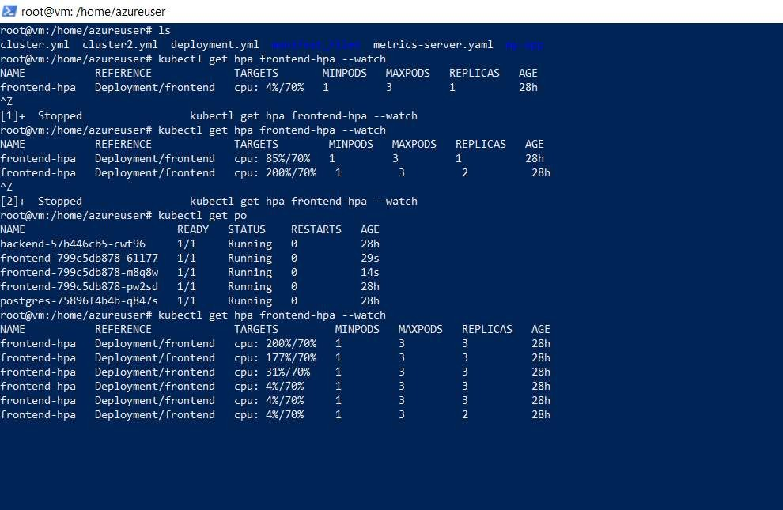
The HPA wilsl check the frontend pod in every 60 seconds and terminate the extra pod

